SOWIT Video Series – “Opportunity Only Knocks Once”
(Video link: www.edb.gov.hk/sowit_opportunity)

Lesson Plan

Suggested Levels
Upper Primary/Junior Secondary
Summary of the Learning Task
Students watch the SOWIT video “Opportunity Only Knocks Once”, which is about the different approaches adopted by two characters in looking for the treasure in a hidden reef – one man was well-prepared and found the treasure during the low tide while the other had a lot of hesitation and missed the opportunity. Students are then guided to understand the meaning of the saying “Opportunity only knocks once”, learn about the related positive values and attitudes (e.g. be proactive, be positive), write a letter to give advice using conditional sentences, and design a poster to encourage their schoolmates to be proactive.
Learning Objectives
Content
- To understand the meaning of the saying “Opportunity only knocks once.” through a story presented in the context of a video

Language
- To analyse the personality and attitude of the main characters in the video
- To give advice using the conditional sentence “If I were you, I would…”

Values and Attitudes
- To cultivate positive values and attitudes (e.g. be proactive, be positive)

Sharing Learning Intentions
1. Introduce the objectives of the learning activities

Pre-viewing
Part A: Making Predictions about the Story Elements
- Refer students to Activity Sheet: Part A.
- Show students the pictures below, which depict some of the scenes of the SOWIT video “Opportunity Only Knocks Once”:
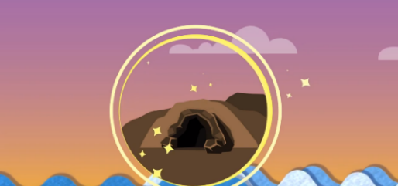
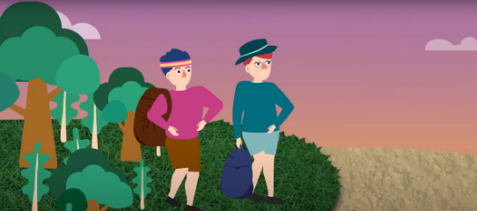

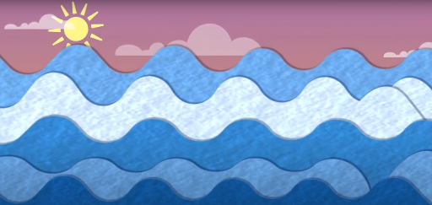
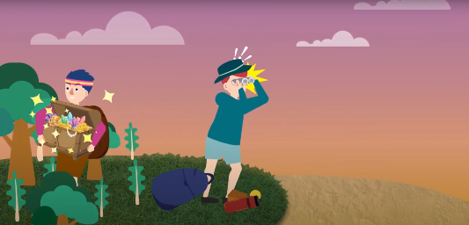

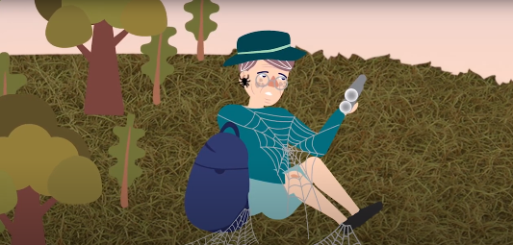

- Guide students to make predictions about the story elements by drawing their attention to the visual clues captured in the pictures (e.g. the cave, the jewels, the sea level, the facial expression of the characters).
- Discuss with students their observations.

Viewing
Part B: Analysing the Personality and Attitude of the Characters
- Refer students to Activity Sheet: Part B.
- Instruct students to scan the questions and pictures in Question 1.
- Play the video “Opportunity Only Knocks Once”.
- Instruct students to fill in the blanks while watching the video.
- Go over the answers with students.
- Analyse the personality and attitude of the characters with students.

Post-viewing
Part C: Giving Advice Using Conditional Sentences
- Refer students to Activity Sheet: Part C.
- Introduce the use of the conditional sentence “If I were you, I would …” to give advice.
- Invite students to give the man in green some advice using the conditional sentence “If I were you, I would…” through revisiting some scenes in the video.

Part D: Understanding the Saying of Wisdom
- Refer students to Activity Sheet: Part D.
- Revisit the meaning of the saying “Opportunity only knocks once.” with students (i.e. since opportunity only knocks once, we should be well-prepared, seize and cherish it to avoid any lifelong regrets).
- Invite students to reflect on an opportunity they have missed and what they would do if they were given the opportunity again.
- Instruct students to design a poster to remind their schoolmates of the importance of seizing every opportunity and convey the message of “Opportunity only knocks once”. Brainstorm possible titles, images and context to use with students.
- Select a few posters and invite students to introduce their design.

SOWIT Video Series – “Opportunity Only Knocks Once”
Activity Sheets

(Pre-viewing)

Part A: Making Predictions about the Story Elements

- Study the pictures below, which depict some of the scenes of the SOWIT video “Opportunity Only Knocks Once”. What do you think the video is about? Write down your thoughts in Boxes (a) – (d).

- Where did the story take place?

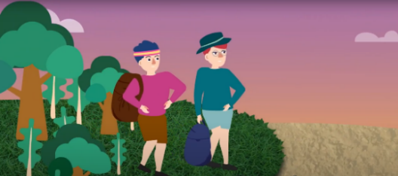

- What were the two main characters looking for?

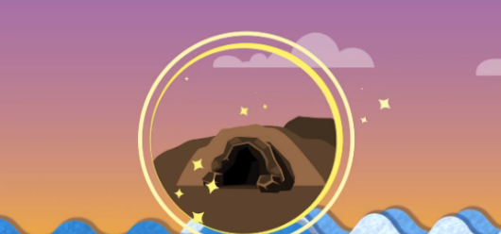

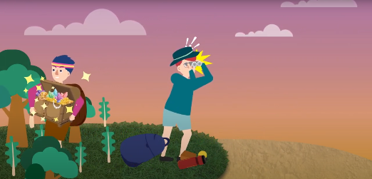
- What had happened?

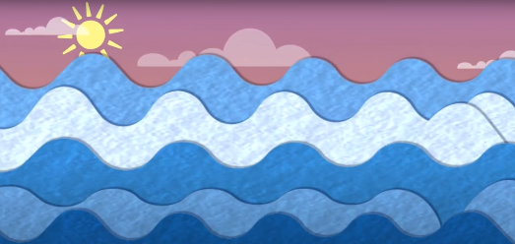

- How did the man in green feel at last?

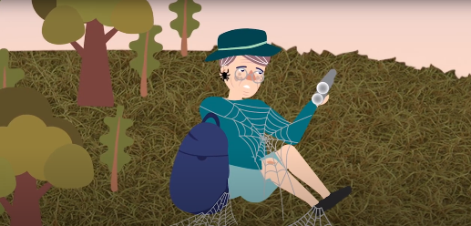

(Viewing)

Part B: Analysing the Personality and Attitude of the Characters

- The strong man (the man in pink) and the slender man (the man in green) in the story have very different personalities. Analyse their personalities and attitudes by completing the table below. Fill in the blanks with the most appropriate words and put a tick () in the boxes provided. The words may or may not appear in the video.

- While waiting for the low tide
What did they do? | What was their attitude?
The man in pink did a lot of (a) e__________ to keep his body strong and fit. | (b)  proactive  passive  hesistant  confident
The man in green was (c) s___________ on the grass and using the binoculars to observe the tide. He was (d) t___________ about when the tide would go out. | (e)  proactive  passive  hesistant  confident

- When the tide ebbed
What did they do? | What was their attitude?
The man in pink was (f) w_____-p__________ and physically strong. He made a dash for the passage. He found the treasure (g) s_________________. | (h)  risk-taking  conservative  decisive  indecisive
The man in green packed his water bottle, but did not take any further actions like the man in pink. He kept thinking if the tide would come in when he was halfway there. He was (i) w_________ that he would get drowned in this dangerous situation. | (j)  risk-taking  conservative  decisive  indecisive

- Ending
What happened to them at last? | How did they feel?
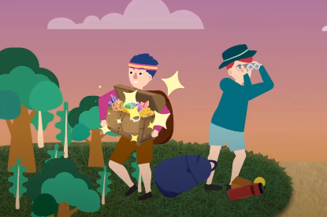  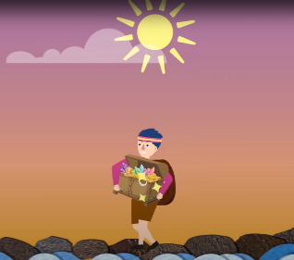  The man in pink returned to the shore while the tide was still low. He became (k) r_______. | (l)  regretful  satisfied  happy  bitter
Suddenly, the tide turned so quickly. The man in green was not (m) r________ and he had no choice but to stay at the beach. He continued (n) w_________, but there was no knowing when the next tide would come. | (o)  regretful  satisfied  happy  bitter

- What qualities can you learn from the man in green and the man in pink?
__________________________________________________________________
__________________________________________________________________

(Post-viewing)

Part C: Giving Advice Using Conditional Sentences
- The man in green waited and missed the chance. If you were the man in green, what would you do when the tide first subsided? Give him three pieces of advice using the following language structure:

If I were you, I would…

e.g. If I were you, I would not sit and wait.

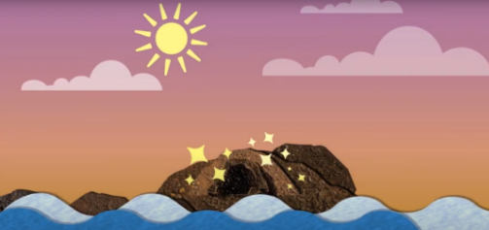

Advice for the man in green (The pictures below will help you brainstorm ideas.):

- ___________________________________________________________

- ___________________________________________________________

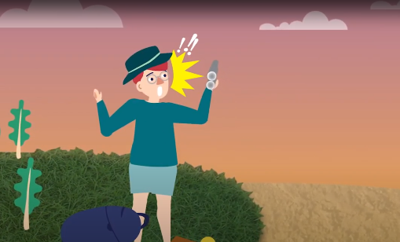
- ___________________________________________________________

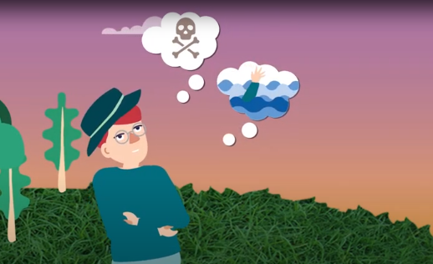
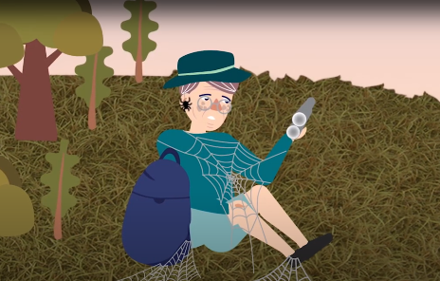
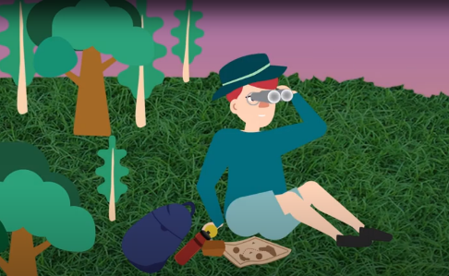

Part D: Understanding the Saying of Wisdom
- What is the message conveyed by the story?
_________________________________________________________________
_________________________________________________________________

- What is the meaning of the saying “Opportunity only knocks once”?
___________________________________________________________________
___________________________________________________________________

- Did you have any experience of missing a chance of doing something that you really wanted to do? What was it? How did you feel at that time? If there were an opportunity again, what would you do? Complete the table below and share your ideas with your classmates.
An opportunity that I missed
What?
What opportunity did you miss?
When?
When did it happen?
Why?
Why did you miss the chance?
How?
How did you feel at that time?
What have you learnt from the experience?
If there were an opportunity again, what would you do?

- Design a poster to be displayed in your school to encourage your schoolmates to seize every opportunity and convey the message of “Opportunity only knocks once”.

Consider the following when designing the poster:
  - Think of a situation that your schoolmates may encounter
  - Use of eye-catching images
  - Use of an attractive title/slogan

SOWIT Video Series – “Opportunity Only Knocks Once”
Activity Sheets (Suggested Answers)

Part A: Making Predictions about the Story Elements
- (a) An island
(b) They were looking for treasure.
(c) The man in pink found the treasure but the man in green did not. The tide rose
again.
(d) He felt unhappy/bitter/sad/disappointed.
(Accept any reasonable answers.)

Part B: Analysing the Personality and Attitude of the Characters
- While waiting for the low tide
- (a) exercise
(b) proactive confident
(c) sitting
(d) thinking
(e) passive hesistant

- When the tide ebbed
- well-prepared
- successfully
- risk-taking decisive
- worried
- conservative indecisive

- Ending
- rich
- satisfied happy
- ready
- waiting
- regretful bitter

- Man in pink: proactive, confident, decisive, risk-taking, determined
Man in green: cautious, careful
(Accept any reasonable answers.)

Part C: Giving Advice Using Conditional Sentences
- (i) If I were you, I would do more exercise to make myself fit.
- If I were you, I would not be hesitant and I would walk through the passage.
- If I were you, I would not be disappointed when I missed the first chance of the low tide and get well-prepared for the second chance.
(Accept any reasonable answers.)

Part D: Understanding the Saying of Wisdom
- Since opportunity only knocks once, we should be well-prepared, seize and cherish it to avoid any lifelong regrets.
- We should grab every opportunity as if it were the only one in our life as opportunity may only come once.
- Accept any reasonable answers.
- Accept any reasonable answers.

